M D. TOZAMMEL HOSSAIN
 | Address | Road # 7, House #16  6th Floor (A), Senpara Parbata,  Mirpur-10, Dhaka-1216.
 |  | +8801743943363
 |  | tozammel.ca@gmail.com
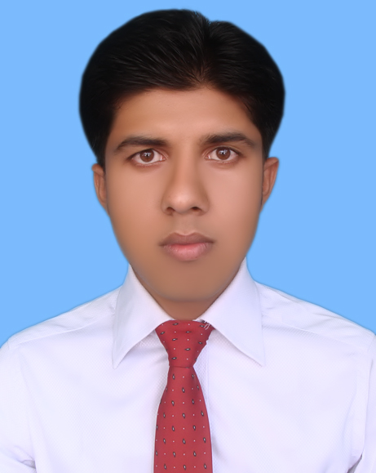

Career Objective

Want to play a vital role in the rapid progress of the organization with my professional knowledge, integrity, honesty and strong effort to the organization especially in the field of finance, accounts, audit and internal control and to secure a better position in the corporate world as well.

Quick Profile & Key Qualifications

I am now working in BSRM Group of Companies as an Assistant Executive Accounts. I have completed CA (CC) from M M RAHMAN & CO. Chartered Accountants and in this time I have passed three papers. I have completed MBA from Jahangirnagar University with CGPA 3.23 out of 4.00 and BBA from IBAIS University with CGPA 3.83 out of 4.00. I passed H.S.C & S.S.C from Government Debendra College, Manikganj and Manikganj Government High School with GPA 4.00 & 4.56 respectively.

Professional Skills

- Preparation of financial statements as per applicable rules and regulations.

- Preparation of Tax Accounts, To submit Tax Return & VAT Return.

- Advising and assisting in preparation and maintenance of books of accounts, i.e. Ledger, Cash book, Voucher etc.

- Prepare bank reconciliation and posting financial transaction.

- Monthly Salary sheet, Sales report, sales against cost report preparation.
- Preparation of Management Report
- Ability to carry out internal auditing function and internal control system.

Work Experience

I am now working in BSRM Group of Companies as an Assistant Executive Accounts Department of Finance & Accounts from 29th November 2018 to till now. I work in the field of sales account, to prepare bank reconciliation, to maintain receivable ledger and aging schedule etc.

Major Professional Assignments Handled

- UTTARA Bank Limited

Bank and Financial Institutions
- Prime Finance Capital Management Limited
- Prime Finance Asset Management
- PFI Securities Limited
- Prime Islami Securities Limited
- Parkway Securities Limited

- Queen South Textile Mills Limited (DEPZ)

Manufacturing
- BMS Rope Co. Limited (CEPZ)
- Intercontinental Technology Limited (CEPZ)
- Sun Cherry Body Fashion (Mfty) Limited
- Yokohama Labels and Printing (BD) Co. Ltd. (AEPZ)
- Paddock’s Jeans Limited (DEPZ)
- Redpoint Jackets Limited (DEPZ)

NGOs
- Gram Unnanyan Karma (GUK)
- Come To Work (CTW)

- Dhaka Chamber of Commerce & Industry (DCCI)
Service
- Bangladesh Eye Hospital

Real Estate
- Navana Real Estate Limited

Specialization

- Accounting & Finance  - Audit  - Tax & Vat  - Tally Software | I can make any types of Financial Statements in according to (BFRS) moreover I can manage Tax & Vat Related Matters another Expertise field that I feel management reporting.

Professional Qualification

Enrolled as an Articled Student for three years professional course of Chartered Accountancy from The Institute of Chartered Accountants of Bangladesh (ICAB) under the supervision of Mr. M. Obaidur Rahman, FCA and Senior Partner of M M RAHMAN & CO. Chartered Accountants. My professional education qualifications are given below:
Level | Firm | Institute | Position
PS Certificate Level | M M RAHMAN & CO. | ICAB | 3 Papers completed

During the period in M M RAHMAN & CO (September 9, 2015 to September 8, 2018), I have been engaged in various organizations for audit, preparation of accounts and consultancy which offered me an immense opportunity to have an extensive and in depth experience of different kind of working environment.

Academic Qualification

Post Graduation | M.B.A. (Major in Accounting & Information System)  Faculty of Business Administration (FBS)  Department of Accounting & Information System  Jahangirnagar University  CGPA= 3.23 (Scale of 4.00)
Graduation | B.B.A. (Major in Accounting)  Session: 2009-2010, Passing Year: 2014  Faculty of Business Administration  Department of Accounting & Information System  IBAIS University  CGPA= 3.83 (Scale of 4.00)
Higher Secondary Certificate | Board: Dhaka, Group: Business Studies  Session: 2006-2007, Passing Year: 2008  Government Debendra College, Manikganj  G.P.A= 4.00 (Scale of 5.00)
Secondary School Certificate | Board: Dhaka, Group: Business Studies  Session: 2004-2005, Passing Year: 2006  Manikganj Government High School, Manikganj  G.P.A= 4.56 (Scale of 5.00)

Computer Literacy

Accounting Software | Oracle, Tally
Microsoft Office | Word, Excel, Power Point 2003, 2007, 2010, HTML, SPSS, MS Access
Operating Systems | Windows XP, Windows Vista, Windows 2007,2008,2010

Language Proficiency

Languages | Speaking | Listening | Reading | Writing
Bangla | Excellent | Excellent | Excellent | Excellent
English | Excellent | Excellent | Excellent | Excellent

Personal Information

Full Name | Md. Tozammel Hossain
Father’s Name | Md. Shahed Ali
Mother’s Name | Sakhina Begum
Nationality | Bangladeshi (by birth)
Religion | Islam
National ID No. | 5612283866253
Date of Birth | The 1st March, 1990
Marital Status | Single
Permanent Address | C/O: Md. Shahed Ali  Village: Char Maize Khara, Post : Boikuntopur,  P.S: Ghior, District: Manikganj.
Contact Details | Road # 7, House # 16 , 6th Floor (A), Senpara Parbata  Mirpur-10, Dhaka-1216  Cell No: 01743943363  E-mail : tozammel.ca@gmail.com

References

Mr. M. Obaidur Rahman, FCA  Partner  M M RAHMAN & CO.  Chartered Accountants  Padma Life Tower, Level-10  115 Kazi Nazrul Islam Avenue  Bangla Motor, Dhaka-1000  Phone: +88029561605 | Mohammad Forkan Uddin, FCA  Partner  M M RAHMAN & CO.  Chartered Accountants  Padma Life Tower, Level-10  115 Kazi Nazrul Islam Avenue  Bangla Motor, Dhaka-1000  Mobile: +8801819-239298  Email: forkan@mmrahman.org

Declaration

"I certify that all information stated in this CV is true & complete to the best of my knowledge. I authorize the authority to verify the information provided in this CV”



Date: 8th June, 2019

Md. Tozammel Hossain

